Penetration Testing an API for the Broken Object Level Authorization (BOLA)

Penetration Testing an API for the Broken Object Level Authorization (BOLA) 1
Create a real user with Postman.com with a valid email address. 2
OWASP crAPI 4
Next we must register our car in the craAPI website 4
Next we will use the Developer tools in Chrome to look at API responses 6
Find the Bearer token for Authorisation 7
Next we would like to investigate the JSON data returned for the Vehicle owned 9
Next investigate the data returned about the location of the vehicle 10
Next you would participate in the community forum of the website 11
Next we want to find another customers vehicle location 11
The next objective is to find a vehicleid for a vehicle that you would like to locate 12
The next objective is to find the location of a vehicle by creating an API Request using Postman 12
Reflection 14
Extra Challenge: 15
Access mechanic reports of other users 15

The objectives of this activity are :
- To register a real user on Postman
- To register a fake user and password on the crAPI website
- To investigate API requests and responses using Postman
- To obtain a Bearer Token which can be used for Authorisation
- To store the Bearer Token in Postman Authorization header
- Use the crAPI website and email server to register a car
- To post a topic on the crAPI Community Forum
- To discover a Vehicle ID by capturing the API requests for Forum Posts
- To locate a vehicle which belongs to another user using the Vehicle ID

Create a real user with Postman.com with a valid email address.
Postman is an API platform for building and using APIs.
Postman simplifies each step of the API lifecycle and streamlines collaboration so you can create better APIs—faster.
Postman can be used for API functionality testing and Penetration Testing for API security this is what we will use it for in this lab.
Sign up to Postman You can use a temporary email address if you do not want to reveal yours
Temp-mail.org
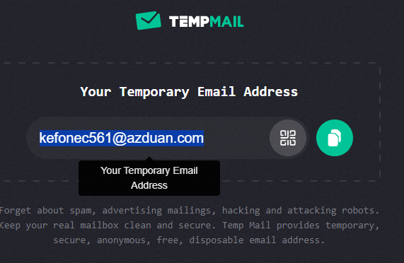
Figure 1 Temporary email address
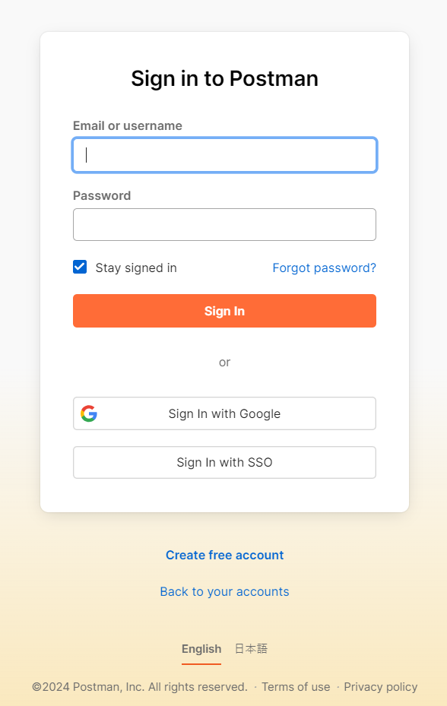
Figure 2 Register with Postman.com
Register with Postman.com using the temporary email address and create a password
Login to Postman https://www.postman.com/
In the Postman website
-select Workspaces
-select create Workspace
-select blank workspace and click next
-give the workspace a name eg crAPI and click create 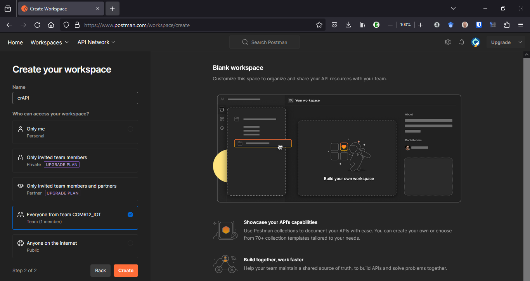
Figure 3 Create a Workspace called crAPI in Postman

OWASP crAPI
crAPI is a Penetration testing server which is a fake mechanics website with vulnerable APIs
Go to the crAPI website crAPI.
Sign up to the crAPI system using a fake email address and username.
You can make these up any name and a fake email
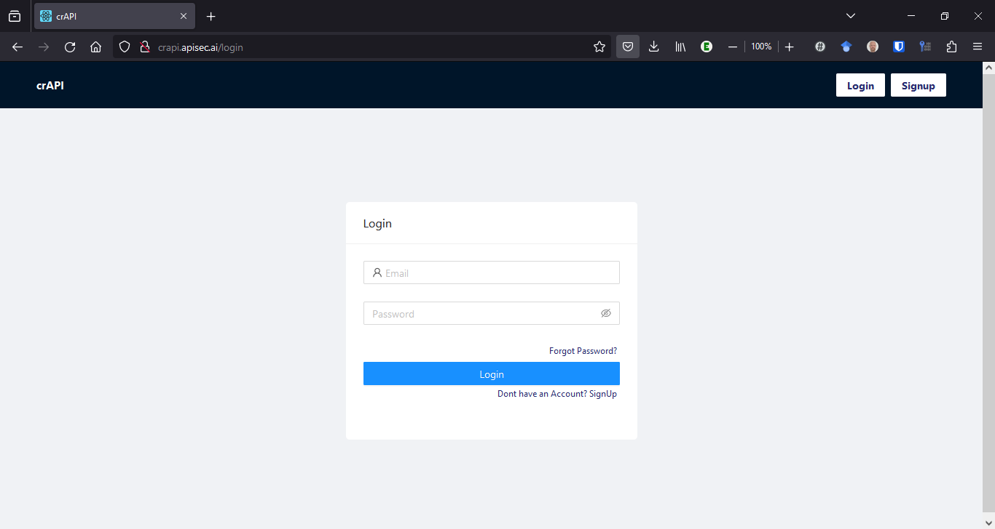
Figure 4 Register with crAPI

Next we must register our car in the craAPI website
Click the add a vehicle button.
The Pin Code and VIN are sent in an email but it is not a real email address it is the fake one that you entered .
To read this email we must go to a fake email server called Mailhog also created by OWASP
This is not accessible on the University Network
- see the lecturers or helpers in the class and they can get your details on a laptop.
You will require your welcome to crAPi email with a Vehicle Identification Number VIN number and a PIN number

Go back to crAPi and click on Add vehicle and add the details provided by the helpers
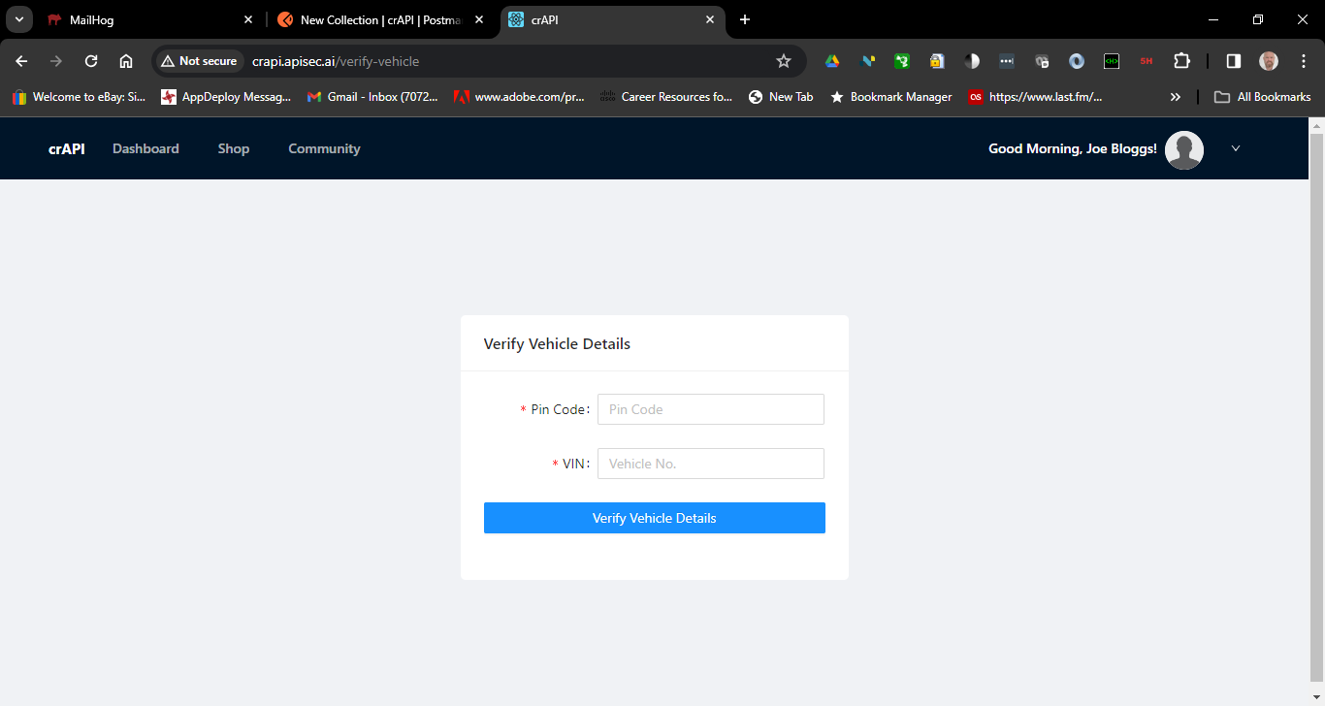
Figure 7 Enter Vehicle details
The Vehicle details should be added to your crAPi account
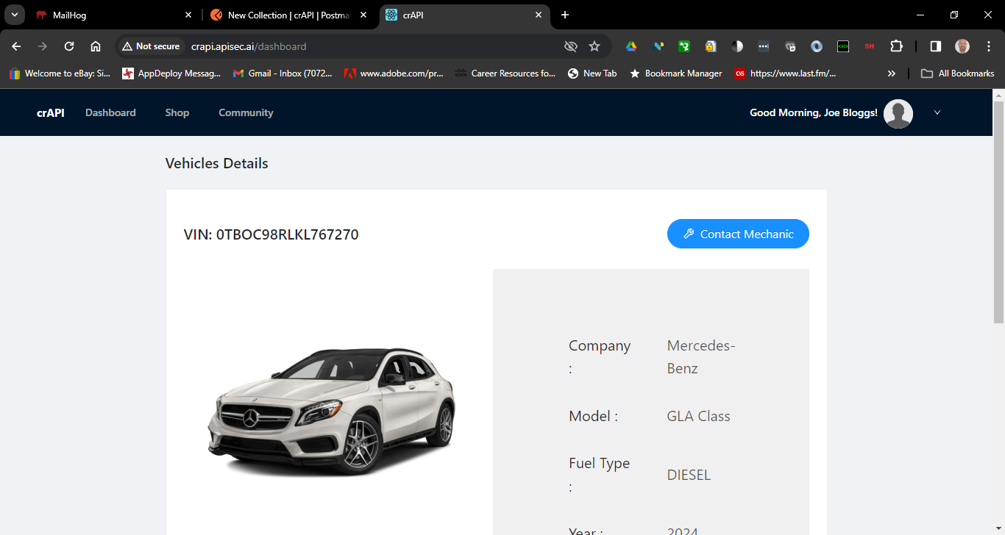
Figure 8 crAPi Vehicle Details
You can also see your vehicle location if you scroll down
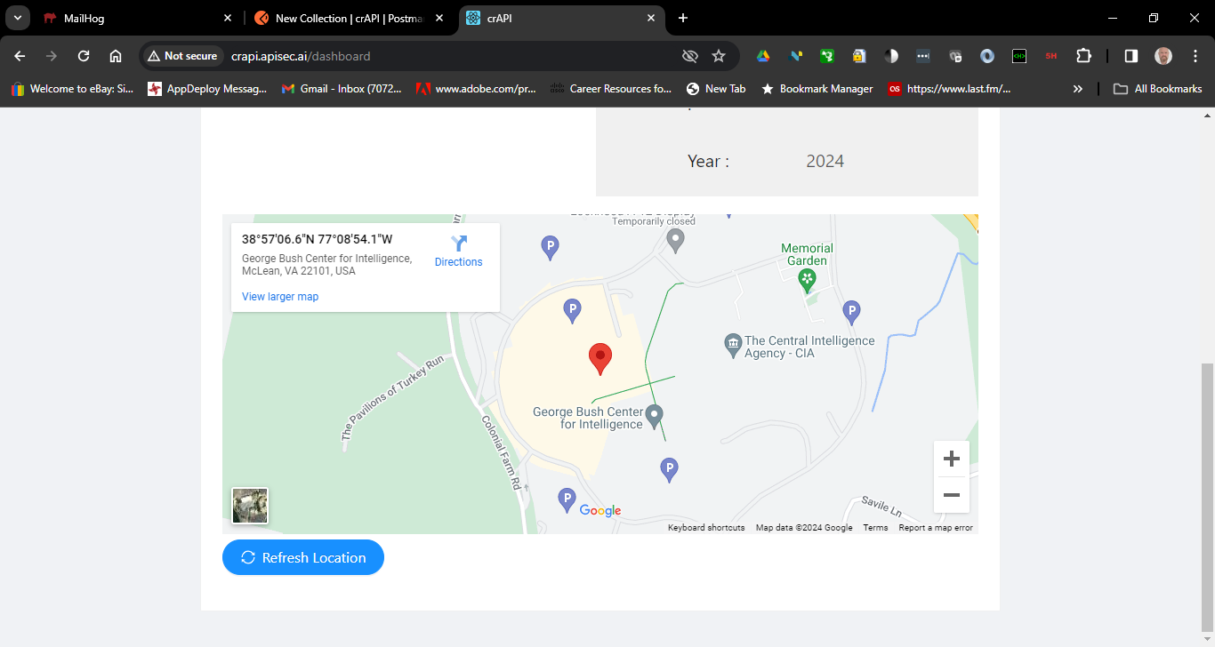
Figure 9 crAPi vehicle Location

Next we will use the Developer tools in Chrome to look at API responses
In Google Chrome select Customise and control which is the three dots on the right
Scroll down the menu and select – more tools – Developer tools
If the Developer tools are covering a part of the website interface then you can drag them to the right using the mouse cursor on the divider.
Type http://crapi.apisec.ai in the URL bar see Figure 2
Select Logout and Login and retype credentials.

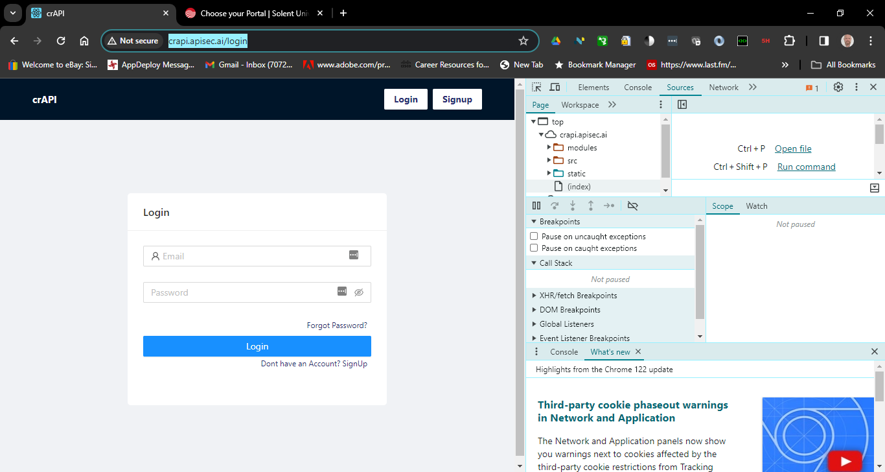
Figure 10 Chrome Developer Tools for website crAPI.apisec.ai

In the Developer Tools in Chrome select the Network Tab
There is a list of Requests on the left of the developer tools find and select login
If the login was successful, the headers will show a POST request with a status of 200 ok
-Select the Response which is the Data sent back.

Find the Bearer token for Authorisation
The Bearer token is in the Request Headers for the GET request this token is used to do Basic Authentication with the crAPI
We will enter this token into Postman application to enable Postman to send authenticated API requests
In the crAPi workspace you will have a new collection which is for adding new Requests to the crAPI website. Postman enables you to store these requests, test them, modify them and delete them. Requests can be used to test the functionality of the website and find vulnerabilities which is called Pen Testing.
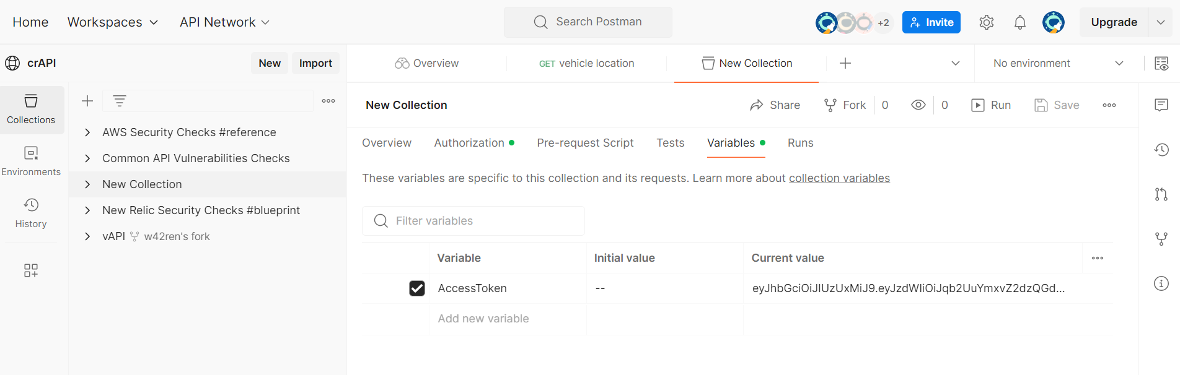
Figure 11 Postman New collection of Requests for crAPI Testing
Click New next to the crAPI
To enable the Requests to authenticate with the crAPI website we must add a Bearer Token as a variable which can be used by all the requests.
To locate the Bearer token use Google Chrome and copy the “token” variable that is in the Response of the login request which you just did to the Postman New Collection

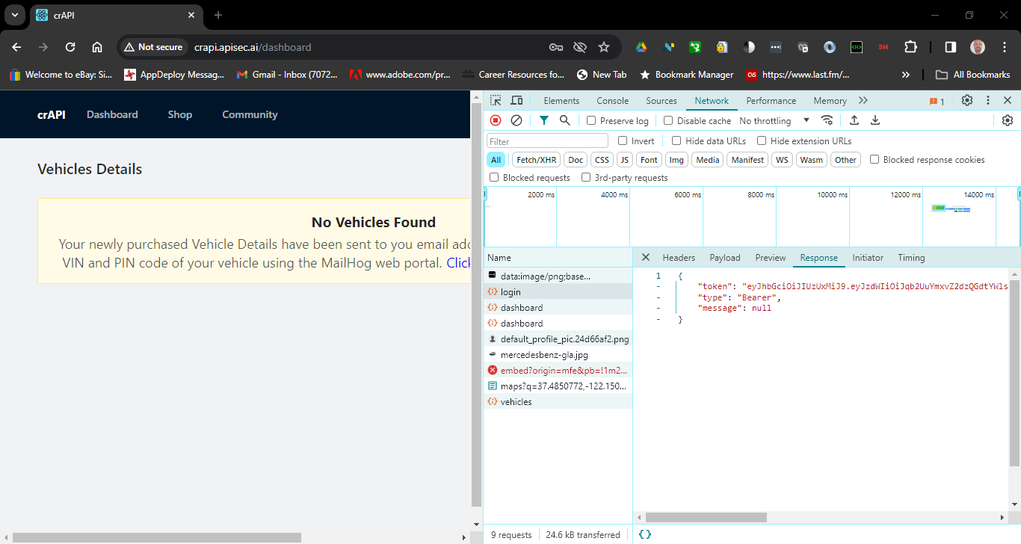
Figure 12select the Login Request from the Chrome Developer tools - Network list
In Postman select the authorization tab under the new collection
-the type should be Bearer token if it is not then select it.
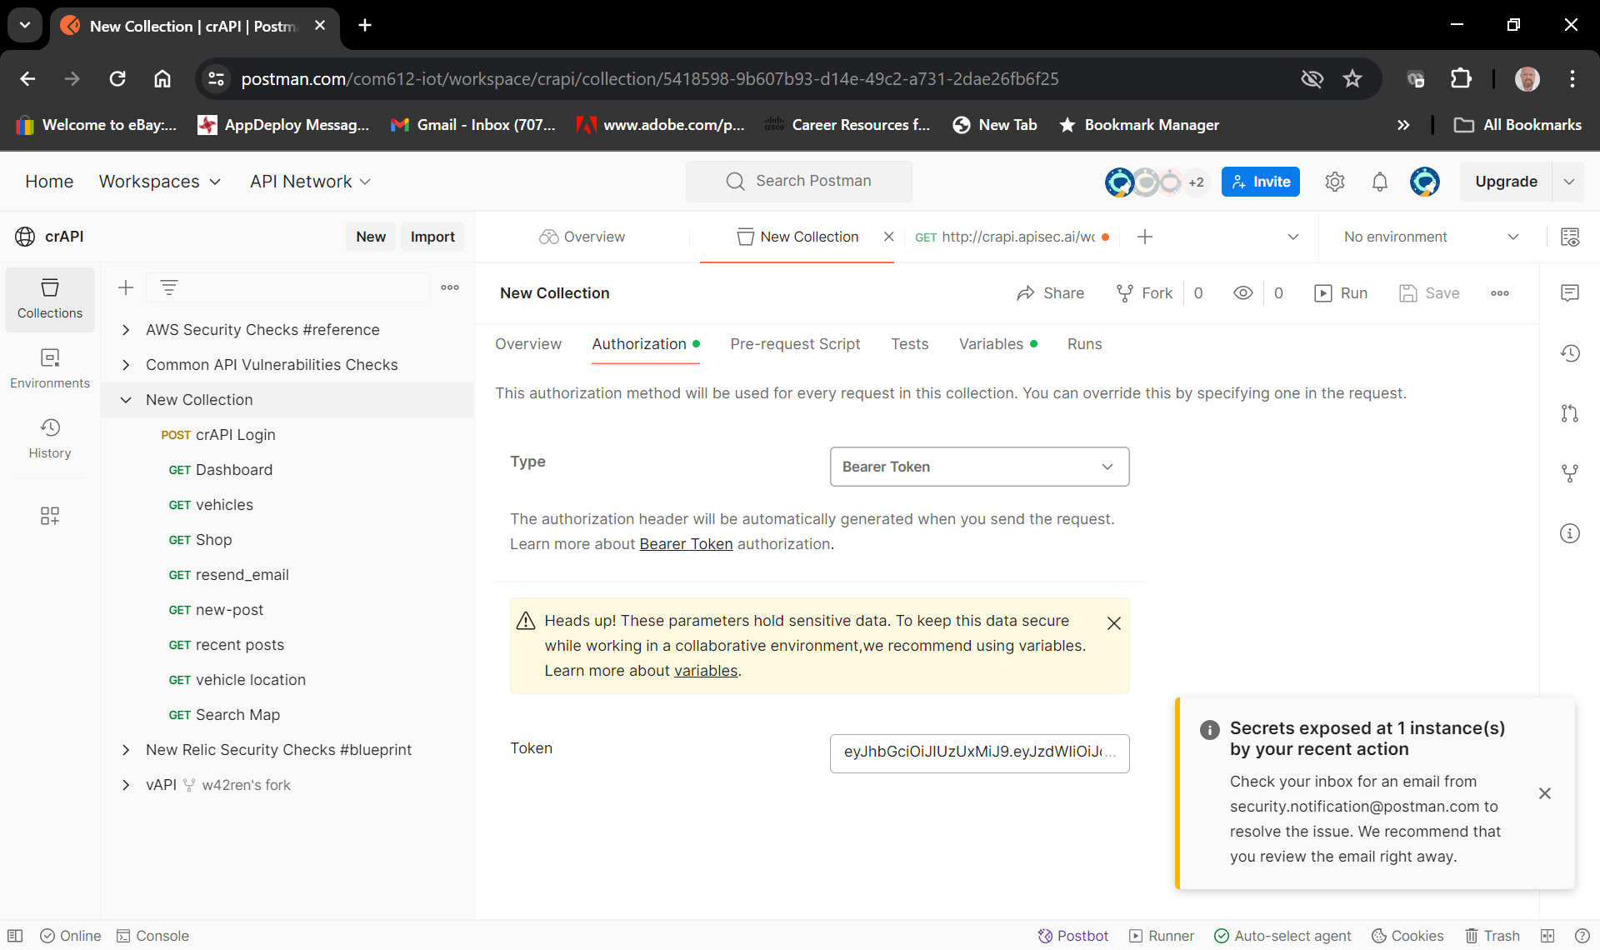
Figure 13 Postman 'New Collection' Requests Authorization set to Bearer Token

You can paste the Bearer Token provided by crAPI which you obtained in the previous step directly into the Token field replacing the variable name {{Access Token}}
In the Current Value paste the Bearer Token which you have copied from the Google chrome Request response data. – the “ at the beginning and the ”; at the end are not required in the variable.
This is not the most secure way to save a token and to make it secure you should save it as a variable therefore you will receive warnings about this in Postman for this exercise it does not matter, as the website is fake.
IMPORTANT click SAVE at the top right of the Collection header
Go BACK to the crAPI web site
-Select the crAPI Dashboard in the menu bar of the web application.

Next we would like to investigate the JSON data returned for the Vehicle owned
-In the developer tools select the Network pane.
-Select the Request called vehicle in the list

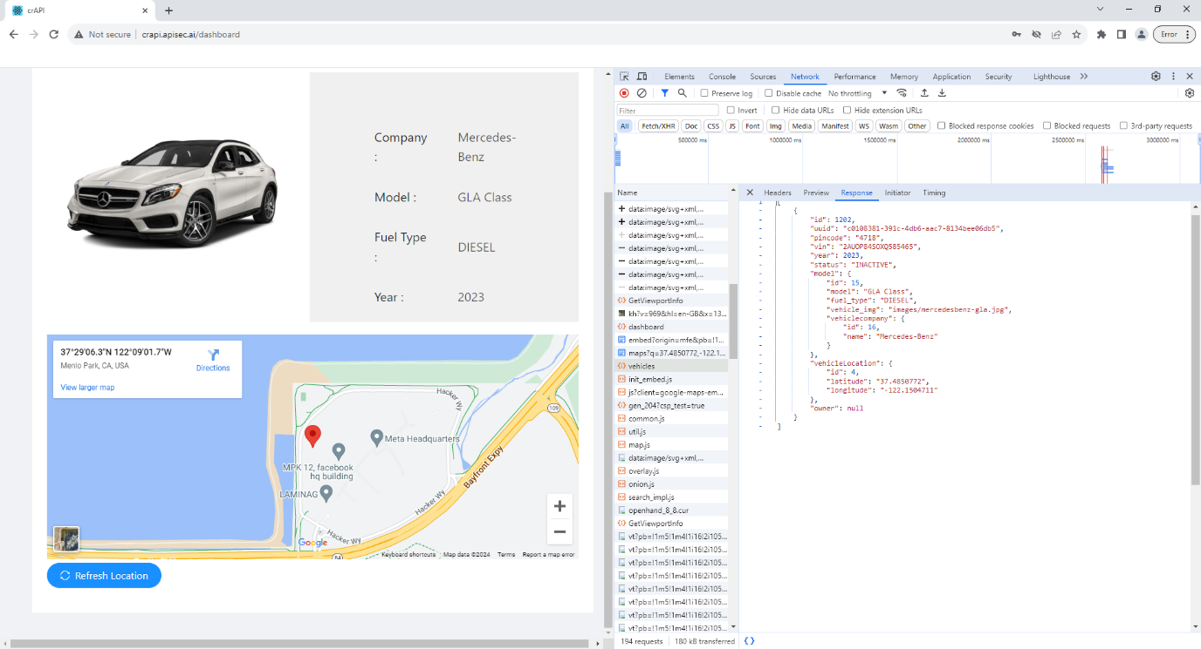
Figure 15 Using the Developer Tools in Google Chrome to examine the GET response from the crAPI website

Next investigate the data returned about the location of the vehicle
Click on the refresh location button on the Dashboard web page.
In the response JSON data there is the vehicle location in Latitude and Longitude coordinates this locates the vehicle on the Map
Latitude and Longitude are coordinates on a map which are passed in the JSON data of the Response in JSON Key Value Pairs
Eg "latitude": "37.4850772",
"longitude": "-122.1504711”


Figure 16 Vehicle location Response Body Data

Next you would participate in the community forum of the website

Click on the Community in the Menu Bar and click + New Post Button
Write a title and a description be imaginative and role play you are posting (boasting) about you amazing car. 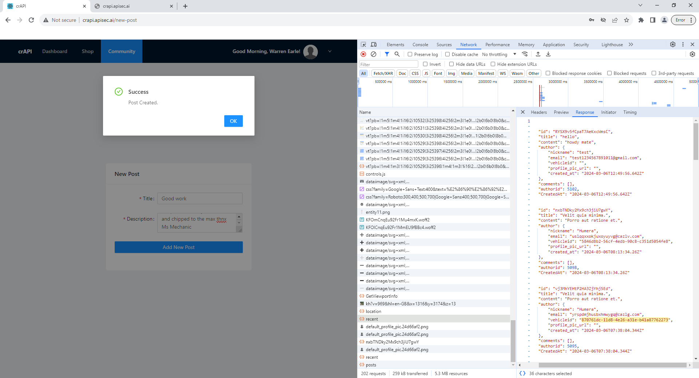
Figure 17 Creating POST on crAPI Community

Next we want to find another customers vehicle location,
To do this we will exploit the BOLA of the objects posted in the forum of the web application.
This is caused by poor development techniques or inexperienced developers.
In the developer tools select the ‘recent’ GET request response network response
In the Recent GET request you can find the JSON data from the body of the request
The next objective is to find a vehicleid for a vehicle that you would like to locate,
The vehicle id can be located from this data which is creating the posts.
The response of the recent posts includes the vehicle id of the users who have posted if they have registered a vehicle on the website
Copy one of the vehicle ids
In this example you can see :
"vehicleid": "c0108381-391c-4db6-aac7-8134bee06db5",
Which belongs to Warren Earle the vehicleid is a ‘JSON key’ and the characters are the value of that key
Image - 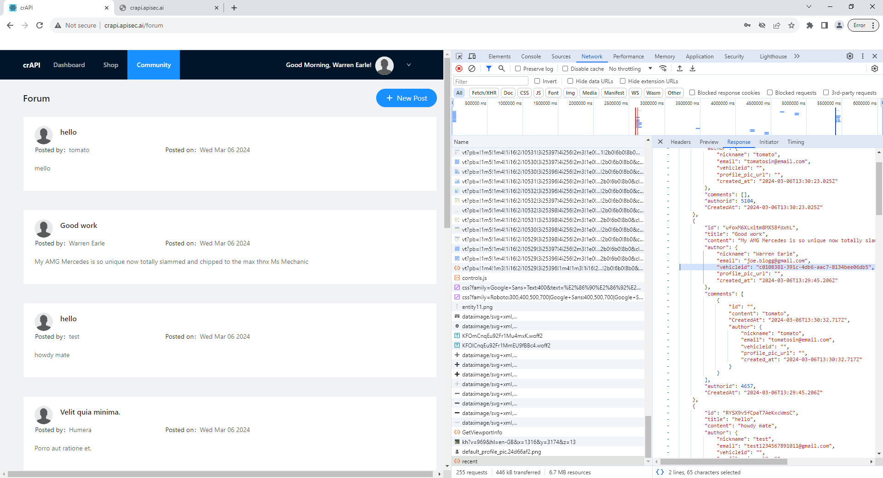

The next objective is to find the location of a vehicle by creating an API Request using Postman
Postman stores the requests you are creating in a collection we can use the collection that you created earlier.
In Postman Highlight New Collection and select Add request
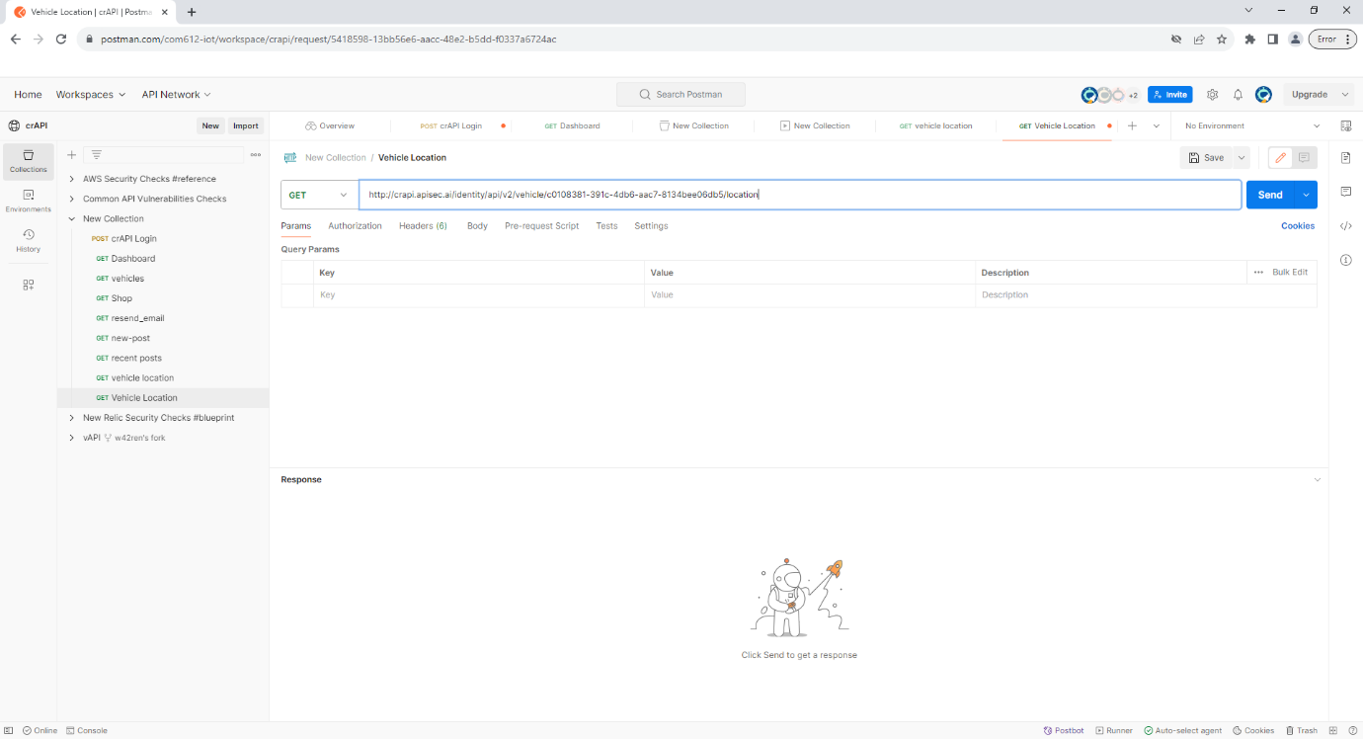

Figure 18 Add request for vehicle location

Choose HTTP
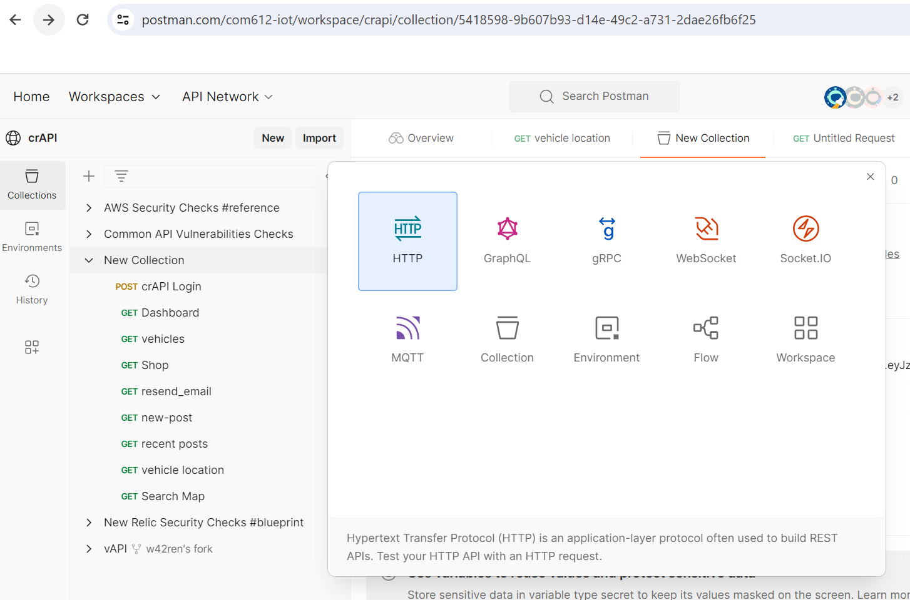
Name it Vehicle location
Add http://crapi.apisec.ai/identity/api/v2/vehicle/vehicle _id_number/location
into the Request box where vehicle _id_number is the id that you copied from the previous step vehicle
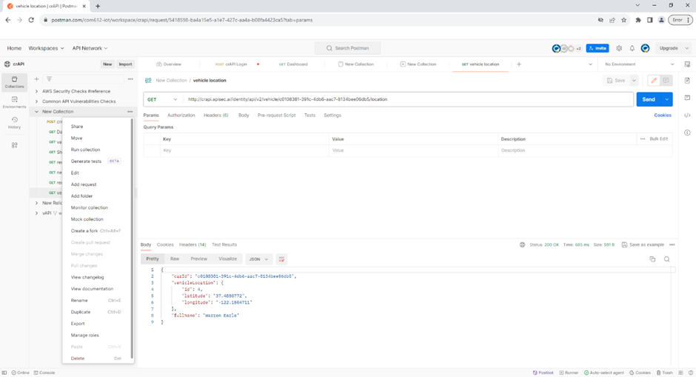
Figure 19 Sent GET request for vehicle location

Click the send button
You have sent a GET request to the location API of crAPI with a vehicle_id of another users vehicle
The JSON data which is in the body of the reply gives the location information of the vehicle.

In this case "latitude": "37.4850772",
"longitude": "-122.1504711”

Reflection
What information did you get about a car which should have been confidential ?
Why was the Object information – the vehicle_id_number Broken and therefore an insecure API ?
How could this be fixed or made more secure ?

Extra Challenge:

Access mechanic reports of other users
crAPI allows vehicle owners to contact their mechanics by submitting a “contact mechanic” form. This challenge is about accessing mechanic reports that were submitted by other users.
- Analyze the report submission process
- Find a hidden API endpoint that exposes details of a mechanic report
- Change the report ID to access other reports

Hints:
Analyse the response when clicking a link that provides access to a mechanic report.
This link included a “report_id” parameter which is a JSON key.
The response also contains a “report_link” which is a formatted version of a request to the API for a mechanics report.
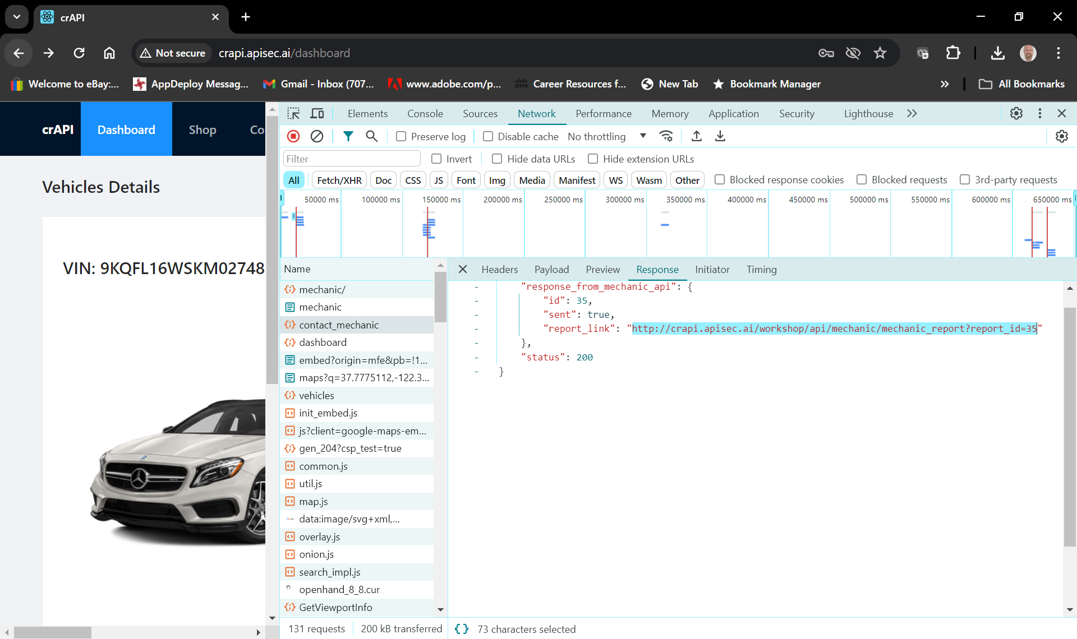
Figure 20 The response from the contact mechanic request showing the report API request
Intercept the request containing the “report_id.” Using Google developer tools
Find the URL for the api request of a mechanics report in the “report_link” JSON key
Access the report associated with “id=X.”
Gain access to another user’s mechanic report.
Enter the report link into a new request in Postman
Analyse the payload of the response in Postman.

